**YOLO Reproduction-3**

Advisor: Dr. Chih-Yu Wang

Presenter: Shao-Heng Chen

Date: July, 20, 2022

1. RDmap dataset structure

D:/Datasets/RD_maps/

├─checks

├─images

├─labels

├─mats

├─mesh_figures

└─scaled_colors

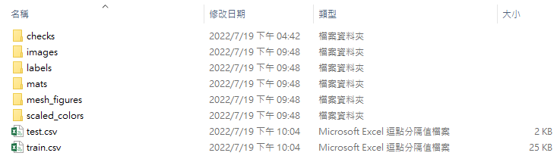

D:/Datasets/RD_maps/labels/122.txt

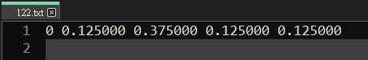

D:/Datasets/RD_maps/labels/checks/ original_coordinates.txt

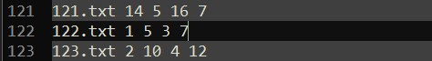

D:/Datasets/RD_maps/scaled_colors/122_sc.jpg

D:/Datasets/RD_maps/mesh_figures/122_mesh.jpg

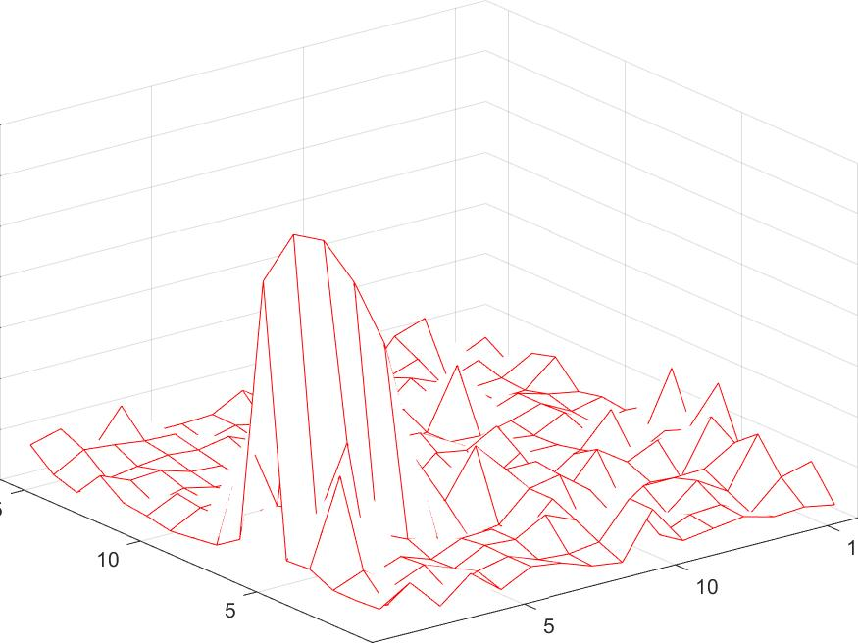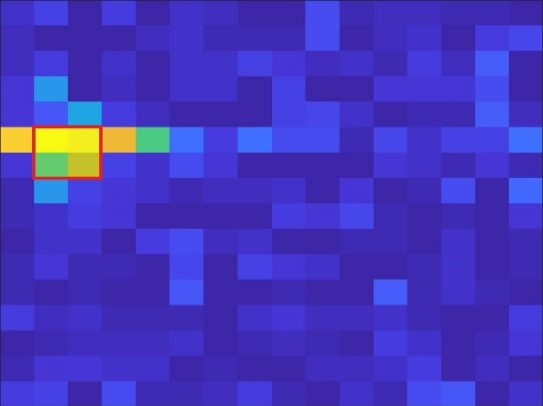

122_sc.jpg 122_mesh.jpg

D:/Datasets/RD_maps/images/122.mat

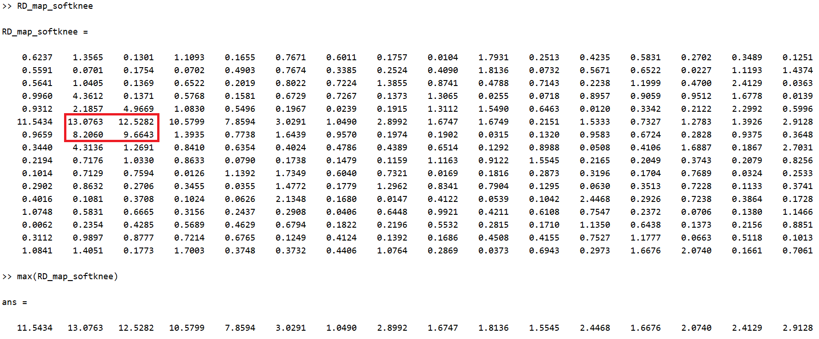

1.1 Dataset problems

(1) Every Anchor box are with fixed size (w, h) = (2, 2)

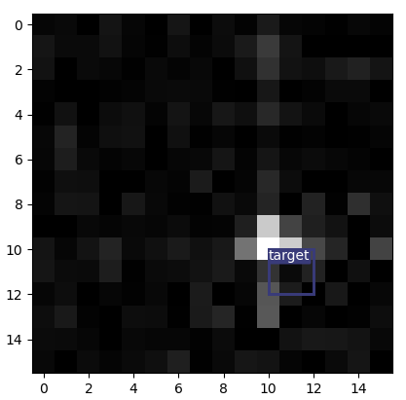(2) Have not figure how to fit .mat files in

(3) Will rescaling dramatically change features? rescale every .mat file to [0, 255] grayscale and store them as 16-by-16 .jpg files, for convenient

(4) In grayscale, the labels seems not correct?

2. YOLOv3 problem

(1) currently untrainable (

(2) the proposed YOLO network seems not the same as the one described in the source code

(3) the output channel (output dimension) of scale prediction seems not [2, 4, 8] but [13, 26, 52]

(4) hyper-parameters like padding, stride size, anchors etc., are not the same as original Darknet, but unspecified?  
(5) my current hyper-parameter settings

